KHQR Code Specification for Retail Payments in Cambodia

Merchant-Presented Mode

Version 1.0
December/2019

Legal Notice

The KHQR specification is adapted from EMV® QR Code specification for Payment System – Merchant-Presented Mode (EMV QRCPS), QR Technical teams (QR Working Group-QRWG) from various Banks, MDIs and PSI had reviewed and changed follow Cambodia’s requirement, after that submitted to Payment Committee in The Association of Banks in Cambodia (ABC) for endorsement. KHQR Code is created for Retail Payment in Cambodia and cross-border payment within ASAIN countries. The EMV® QR Code specifications are provided “AS IS” without warranties of any kind, and the QR Working Group an d its Members neither assume nor accept any liability for any errors or omissions contained in these specifications. The QRWG and its Members DISCLAIMS ALL REPRESENTATIONS AND WARRANTIES, EXPRESS OR IMPLIED, INCLUDING WITHOUT LIMITATION IMPLIED WARRANTIES OF MERCHANTABILITY, FITNESS FOR A PARTICULAR PURPOSE, TITLE AND NON- INFRINGEMENT, AS TO THESE SPECIFICATIONS.

The QRWG and its Members make no representations or warranties with respect to intellectual property rights of any third parties in or in relation to this specification. The QRWG and its Members undertake no responsibility to determine whether any implementation of these specifications may violate, infringe, or otherwise exercise the patent, copyright, trademark, trade secret, know-how, or other intellectual property rights of third parties, and thus any person who implements any part of this specification should consult an intellectual property attorney before any such implementation.

Without limiting the foregoing, this specification may provide for the use of public key encryption and other technology, which may be the subject matter of patents in several countries. Any party seeking to implement this specification is solely responsible for determining whether its activities require a license to any such technology, including for patents on public key encryption technology. The WG and its Members shall not be liable under any theory for any party’s infringement of any intellectual property rights in connection with this specification.

QR Code is a registered trademark of DENSO WAVE.

Revision History

Date | Version | Amendment / Change Description
December 2019 | 1.0 | Initial publication

Table of Contents

1. Introduction ...................................................................................................5
2. Overview of EMV® QR Code Specification for Payment Systems (EMV QRCPS).6
2.1 Notational Conventions ................................................................................ 6

3. Common use cases .........................................................................................8
3.1 Static QR Code ...............................................................................................8

3.2 Dynamic QR Code .......................................................................................... 9

4. | 4.1 | QR Code Payload Data Objects......................................................................11  QR Code Conventions.................................................................................. 11
 | 4.2 | Merchant Account Information .................................................................. 12
 | 4.3 | Additional Merchant Information ..............................................................14
 | 4.4 | Transaction Value ........................................................................................ 16
 | 4.5 | Additional Data Template ........................................................................... 18

Annex A: Members of QR Working Group on KHQR Code Standard for Retail
Payments in Cambodia

1. Introduction

In September 2019, the Working Group on Common QR Code Standard for Retail Payments in Cambodia (the “WG”) was established. The WG aims to develop a common QR code specification for retail payments in Cambodia, which will facilitate merchants, especially SMEs, in using a single QR code to accept payments via different payment service operators. Members of the WG include the Cambodia Monetary Authority, payment network operators, banks, stored-value facility (SVF) licensees and merchant acquirers. A full list of the WG Members is at Annex A.

The standardization of QR code specification for retail payments will help promote wider use of mobile retail payments in Cambodia and provide consistent user experience for merchants and consumers. It can enable interoperability in the payment industry. By prescribing a QR code standard, it will enable the use of a single common QR code that can encompass QR code payment solutions from multiple payment service operators. A common QR code would facilitate payments among different payment schemes, e-wallets and banks and would encourage small merchants to adopt QR code as a payment method.

The WG agreed to focus the work on a common merchant-presented QR code. Having studied various options, the WG agreed to develop a common QR code specification by using the EMV® Merchant-Presented QR Code Specification for Payment Systems (EMV QRCPS) published by EMVCo1 as a basis, as it offers an effective solution to ensure interoperability. This specification should be read in conjunction with the EMV QRCPS. The notational conventions used in this specification are the same as those used in EMV QRCPS.

1 EMVCo is the global technical body that facilitates the worldwide interoperability and acceptance of secure payment transactions by managing and evolving EMV® Specification and related testing processes.

2. Overview of EMV® QR Code Specification for Payment
Systems (EMV QRCPS)

An EMV Merchant-Presented QR Code Payment transaction enables consumers to make purchase using a merchant generated and displayed QR Code based on the merchant’s detail. Follow to the design of the EMV QRCPS, the data within a QR code are organized in a tree-like structure of data objects. A data object may be a primitive data object or a template. A template may include other primitive data objects and templates.

Each data object is made up of three individual fields. The first field is an identifier (ID) by which the data object can be referenced. The second field is a length field that explicitly indicates the number of characters included in the third field, i.e. the value field. A data object therefore comprises the following:

- ID field, which is coded as a two-digit numeric value, with a value ranging from "00" to "99";
- Length field, which is coded as a two-digit numeric value, with a value ranging from "01" to "99"; and
- Value field, which has a minimum length of one character and maximum length of 99 characters.

A common QR code may support multiple payment operators, where individual payment operators may define their own structures of merchant account information and make use of the common data fields, such as transaction currency and amount, contained in the common QR code. Specifically, the EMV Merchant-Presented QR Code supports EMVCo and non-EMVCo payment operators through the use of IDs “02” to “25” for the EMVCo payment operators and IDs “26” to “51” for any payment operators. Individual payment operators may also include some proprietary data in the Additional Merchant Information data objects (See Section 4).

2.1 Notational Conventions

The abbreviations listed in Table 2.1, which is extracted from the EMV QRCPS, are used in this specification.

Table 2.1: Abbreviations

Abbreviation | Description
ans | Alphanumeric Special
C | Conditional
CRC | Cyclic Redundancy Check
ID | Identifier of the data object
ISO | International Standards Organization
M | Mandatory
N | Numeric
O | Optional
QR Code | Quick Response Code
RFU | Reserved for Future Use
S | String
var. | Variable

3. Common use cases

Merchant-Presented QR code enables a merchant presenting a request for payment to a payer, who can then verify the associated information and make a payment to the payee, or reject the request for payment. It supports various payment types, including bill payments, online payments and point-of-sale payments. QR codes are classified into static and dynamic QR codes. The information encoded in a static QR codes are fixed and used for multiple transactions while a dynamic QR code contain additional transaction details such as payment amount and is used for specific transactions.

3.1 Static QR Code

A typical use case of static QR code is payment to small merchants. A florist shop may display a static QR code with merchant account information. Consumers may then scan the QR code with a mobile application to initiate the payment. The merchant’s information, such as shop name, is displayed on the mobile device for verification. The consumer will be prompted to enter a payment amount. Figure 3.1 shows a typical transaction flow of using static QR code to make merchant payment.

Figure 3.1: Transaction flow of Static QR code merchant payment

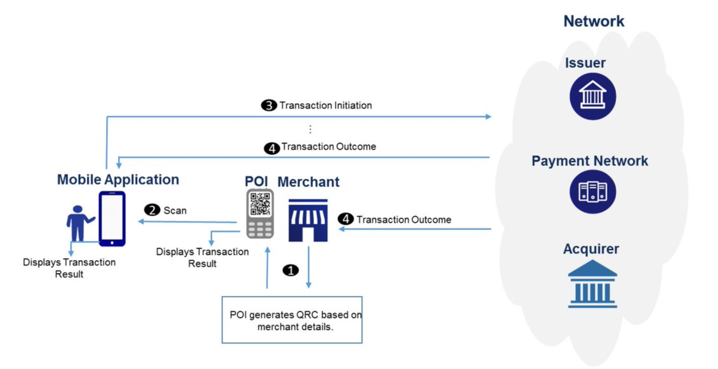

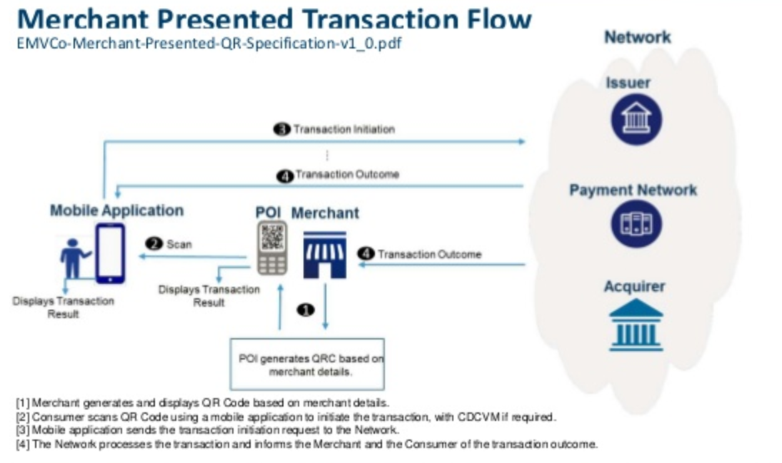

[1] Merchant displays QR Code with merchant details.

[2] Consumer scans QR Code using a mobile application and inputs the amount to initiate the transaction.

[3] Mobile application sends the transaction initiation request to the payment service operator.
[4] The payment service operator processes the transaction and informs the merchant and the consumer of the transaction outcome.

3.2 Dynamic QR Code

Dynamic QR codes are commonly used in online payments, delivery payments, bill payments as well as payments at self-service kiosks. A typical use case of dynamic QR code is payment for online shopping. When a consumer checks out at an online shop, the merchant generates and presents the dynamic QR code, embedded with the essential transaction details, for the consumer to scan with a mobile application to initiate the payment. The merchant’s information (such as Merchant Name) and variable invoice information (such as payment amount) are displayed on the mobile device for verification.

4. QR Code Payload Data Objects

As described in the EMV QRCPS, the content of the QR Code includes the following 5 groups of data objects:
• QR Code Conventions (Table 4.1)
• Merchant Account Information (Table 4.2)
• Additional Merchant Information (Table 4.3)
• Transaction Value (Table 4.4)
• Additional Data Template (Table 4.5)

4.1 QR Code Conventions

The QR Code Conventions (Table 4.1) specify conventions used for the QR Code content, such as Payload Format indicator, which defines the version of the QR Code template and hence the conventions on the identifiers, lengths and values.

Table 4.1: QR Code Conventions

ID | Name | Length | Presence | Remarks
“00” | Payload Format  Indicator | “02” | M | A fixed value of “01”
“01” | Point of Initiation  Method | “02” | O | “11” for static QR Codes; “12” for dynamic QR Codes
“63” | Cyclic Redundancy  Check (CRC) | “04” | M | Checksum calculated over all the data objects included in the QR code

The Payload Format Indicator (ID “00”) shall contain a value of "01". All other values are RFU.

The Point of Initiation Method (ID “01”) shall contain a value of "11" or "12". All other values are RFU. The value of "11" should be used when the same QR Code is shown for more than one transaction and the value of “12” should be used when a new QR Code is shown for each transaction.
The CRC (ID “63”) shall be calculated according to [ISO/IEC 13239] using the polynomial '1021' (hex) and initial value 'FFFF' (hex). The data over which the checksum is calculated shall cover all data objects, including their ID, Length and Value, to be included in the QR Code, in their respective order, as well as the ID and Length of the CRC itself (but excluding its Value). Following the calculation of the checksum, the resulting 2-byte hexadecimal value shall be encoded as a 4-character Alphanumeric Special value by converting each nibble to an Alphanumeric Special character. For example, a CRC with a two-byte hexadecimal value of '007B' is included in the QR Code as "6304007B".

4.2 Merchant Account Information

The Merchant Account Information specifies the identity of a merchant. Each payment operator may define its own format of the Merchant Account Information IDs. Table 4.2A shows the allocation of Merchant Account Information IDs among various payment operators.

Table 4.2A: Merchant Account Information

ID | Name | Length | Presence | Remarks
“02” - “03” | Reserved for Visa | Var. up to  “99” | M One or more data objects (IDs “02” to “51”) shall be included
“04” - “05” | Reserved for Mastercard
“06” - “08” | Reserved by EMVCo
“09” - “10” | Reserved for Discover
“11” - “12” | Reserved for Amex
“13” - “14” | Reserved for JCB
“15” - “16” | Reserved for UnionPay
“17” - “25” | Reserved by EMVCo
“26” | Reserved for Local Debit Card Scheme – Bakong for use in KH
“27” – “28” | Reserved by the WG for use in Cambodia |  |  | These IDs are reserved for future use
“29” - “30” | Reserved for National Payment for use in Cambodia |  |  | “29” Reserved For Remittance  “30” Reserved For Bill Payment
“31” | Reserved by the WG for Payment Innovation (API) |  |  | These IDs are reserved for future use
“32” - “38” | Reserved for additional payment network for use in Cambodia |  |  | These IDs are reserved for future use
“39” - “51” | Reserved for non-bank payment network for use in Cambodia |  |  | Dynamically used by non-bank payment operators for use in Cambodia

The IDs ”26” to “51” are Merchant Account Information templates, which may include primitive data objects and other templates that can be defined by individual payment operators.

The Merchant Account Information template shall contain a primitive Globally Unique Identifier data object with a data object ID "00" to identify the payment operator and the corresponding merchant account information specific to that payment operator (Table 4.2B).

Table 4.2B: Data Object ID Allocation in Merchant Account Information
Template (IDs "26" to "51")

ID | Name | Format | Length | Presence | Remarks
"00" | Globally Unique  Identifier | ans | Var. up to  “32” | M | An identifier to identify the payment operator which uses this template to define the Merchant Account Information  The value is one of the following:  • an Application Identifier  (AID);  • a [UUID] without the hyphen (-) separators; or  • a reverse domain name.
"01"- “99” | Payment network specific | S |  | O | Additional data objects to define the Merchant Account Information specific to the payment operator

The value of the Globally Unique Identifier field shall contain one of the following:

• An Application Identifier (AID) consisting of a RID registered with ISO and, optionally, a PIX, as defined by [ISO 7816-4]. For example, "D840000000".

• A [UUID] without the hyphen (-) separators. For example, “581b314e257f41bfbbdc6384daa31d16”.

• A reverse domain name. For example, “com.merchant.name”.

The value of the Globally Unique Identifier field sets the context for the remainder of the template and the meaning of the other data objects in the template are context specific and outside of the scope of this specification.

4.3 Additional Merchant Information

The Additional Merchant Information (Table 4.3A) specifies the information about a merchant such as merchant name and business location.

Table 4.3A: Additional Merchant Information

ID | Name | Format | Length | Presence | Remarks
"52" | Merchant Category  Code | N | "04" | M | Put a dummy code of “0000” in this field if the payment operator does not use this information
"58" | Country Code | ans | "02" | M | For Cambodia is “KH”
"59" | Merchant Name | ans | var. up to "25" | M
"60" | Merchant City | ans | var. up to "15" | M
"61" | Postal Code | ans | var. up to "10" | O
"64" | Merchant Information - Language Template | S | var. up to "99" | O | A template with other primitive data objects (See EMV QRCPS for details)

The Merchant Category Code (MCC) (ID “52”) shall contain an MCC as defined by [ISO
18245]. The MCC should indicate the Merchant Category Code of the merchant. Put a dummy code of “0000” in the MCC field if the payment operator does not use this information.

The Country Code (ID “58”) shall contain a value as defined by [ISO 3166-1 alpha 2]. The Country Code should indicate the country in which the merchant transacts. Put “KH” in the Country Code field if the merchant transacts in Cambodia.

The Merchant Name (ID “59”) shall be present. The Merchant Name should indicate the “doing business as” name for the merchant. If the QR code information supports only payment operators who supply merchant information via the payment operator’s centralized database, this field may be populated with a dummy code of “NA” in the Merchant Name field. In all other instances, the Merchant Name field must indicate the “doing business as” name for the merchant.

The Merchant City shall be present (ID “60”). The Merchant City should indicate the city of the merchant's physical location. Put “KH” in the Merchant City Code field if the merchant is located in Cambodia.

The Merchant Information – Language Template (ID “64”) is a template, which contains other data fields, which may be used by a mobile application to present the merchant information in an alternate language (Table 4.3B).

Table 4.3B: Data Fields for Merchant Information – Language Template (ID “64”)

ID | Name | Format | Length | Presence | Remarks
"00" | Language Preference | ans | "02" | M
"01" | Merchant Name—Alternate Language | S | Var. up to “25 | M
"02" | Merchant City—Alternate Language | S | var. up to "15" | O
"03"- “99” | RFU for EMVCo | S | var. up to "99" |  | Data objects reserved for  EMVCo

If the Merchant Information – Language Template (ID “64”) is present, the template shall contain the Language Preference field (ID "00") and Merchant Name — Alternate Language field (ID "01"). It may contain the Merchant City — Alternate Language field (ID "02"). All other IDs within the Merchant Information—Language Template are RFU for EMVCo.

The data fields with IDs "01" and "02" are used as an addition to the merchant information under the root. While the equivalent data objects under the root are defined with a format of Alphanumeric Special, and as such can only contain the Common Character Set, the data fields with IDs “01” and “02”, if present, are defined with a format of String, so therefore may contain a different character set.

The Language Preference field (ID “00”) shall contain 2 alphabetical characters coded to a value defined by [ISO 639]. The value should represent the single language used to encode the Merchant Name—Alternate Language field (ID “01”) and the optional Merchant City—Alternate Language field (ID “02”).

4.4 Transaction Value

The Transaction Value data objects (Table 4.4) specify the currency and amount of a transaction. They also include tip or convenience indicators, which allow merchants or customers to specify the convenience fee in fixed value or percentage.

Table 4.4: Transaction Value

ID | Name | Format | Length | Presence | Remarks
“53” | Transaction Currency | N | “03” | M | A numeric code based on [ISO  4217], e.g. put “116” for KHR.
“54” | Transaction Amount | ans | Var. up to “13” | C
“55” | Tip or Convenience  Indicator | N | “02” | O
“56” | Value of Convenience  Fee Fixed | ans | Var. up to “13” | C
“57” | Value of Convenience  Fee Percentage | ans | Var. up to “05” | C

The Transaction Currency (ID “53”) shall conform to [ISO 4217] and shall contain the
3-digit numeric representation of the currency. For example, KHR is represented by the value "116". The value should indicate the transaction currency in which the merchant transacts.

The Transaction Amount (ID “54”), if present, shall be different from zero, shall only include (numeric) digits "0" to "9" and may contain a single "." character as the decimal mark. When the amount includes decimals, the "." character shall be used to separate the decimals from the integer value and the "." character may be present even if there are no decimals. The Transaction Amount shall not be included if the mobile application should prompt the consumer to enter the amount to be paid to the Merchant.

The payment system operators should follow the rules and format in accordance with the EMV QRCPS to process the Transaction Value IDs of the QR Code.

4.5 Additional Data Template

The ID “62” is a template which includes common additional data objects such as Bill Number and Reference Label. It also allows payment operators to define their own additional data objects.

Table 4.5: Additional Data

ID | Sub- ID | Name | Format | Length | Pre- sence | Remarks
“62” | “01” | Bill Number | ans | var. up to “25” | O
 | “02” | Mobile Number | ans | var. up to “25” | O
 | “03” | Store Label | ans | var. up to “25” | O
 | “04” | Loyalty Number | ans | var. up to “25” | O
 | “05” | Reference Label | ans | var. up to “25” | O
 | “06” | Customer Label | ans | var. up to “25” | O
 | “07” | Terminal Label | ans | var. up to “25” | O
 | “08” | Purpose of  Transaction | ans | var. up to “25” | O
 | “09” | Additional Consumer Data Request | ans | var. up to “25” | O
 | “10” – “49” | Reserved for  EMVCo | S |  | O
 | “50” | Reserved for  FPS | S |  | O
 | “51” – “55” | Reserved for the  WG | S |  | O
 | “56” – | Reserved for  Cambodia | S |  | O | Dynamically used by  payment operators for use in

 | “99” | payment system operators |  |  |  | Cambodia

The payment operators should follow the rules and format in accordance with the EMV QRCPS to process the Data Objects for Additional Data Field Template of the QR Code. As the maximum data size of this Additional Data Field Template (ID “62”) is only 99 characters, it is highly recommended that the operators make use of the
pre-defined additional data objects (Sub-IDs “01” – “09”) and avoid defining their own additional data objects in this template so as to prevent data overflow when QR codes of several payment system operators are combined into one common QR Code.

Annex A

Members of Working Group on KHQR Code Standard for
Retail Payments in Cambodia

CIMB Bank PLC
Wing Specialized Bank
ACLEDA Bank PLC
FTB Bank
Angkor Capital

